**SOFTWARE ARCHITECTURE**

Software Architecture consists of One Tier (1- tier), Two Tier, Three Tier and N-Tier architectures.

A “tier” can also be referred to as a “layer”.

Three layers involved in the application namely Presentation Layer, Business Layer and Data Layer.

* **Presentation Layer:** It is also known as **Client layer**. Top most layer of an application. This is the layer we see when we use software. By using this layer we can access the webpages. The main functionality of this layer is to communicate with Application layer. This layer passes the information which is given by the user in terms of keyboard actions, mouse clicks to the Application Layer.  
  For example, login page of Gmail where an end user could see text boxes and buttons to enter user id, password and to click on sign-in.
* **Application Layer:** It is also known as **Business Logic Layer** which is also known as logical layer. As per the Gmail login page example, once user clicks on the login button, Application layer interacts with Database layer and sends required information to the Presentation layer. It controls an application’s functionality by performing detailed processing. This layer acts as a mediator between the Presentation and the Database layer. Complete business logic will be written in this layer.

In a simple word, it is to perform operations on the application.

* **Data Layer:** The data is stored in this layer. Application layer communicates with Database layer to retrieve the data. It contains methods that connects the database and performs required action e.g.: insert, update, delete etc.

In a simple word, it is to share and retrieve the data.

**Types of Software Architecture:**

**One Tier Architecture:**

One Tier application is used for Standalone application

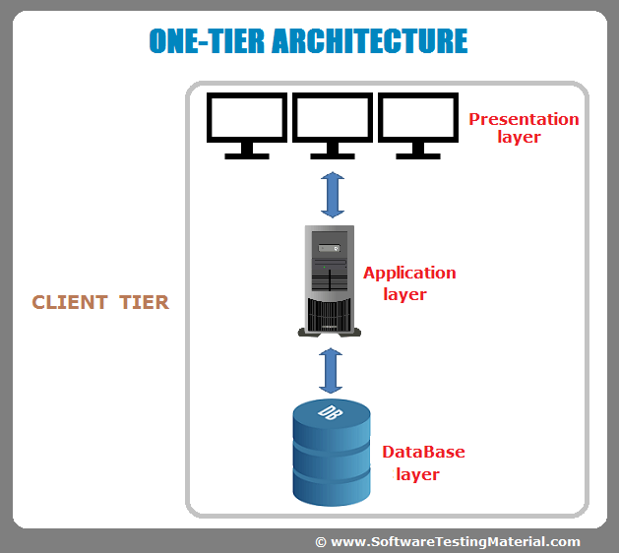

One tier architecture has all the layers such as Presentation, Business, and Data Access layers in a single software package. An application which handles all the three tiers such as MP3 player, MS Office are come under one tier application. The data is stored in the local system or a shared drive.

### ****Two-Tier Architecture:****

Two Tier applications is used for Client-Server application

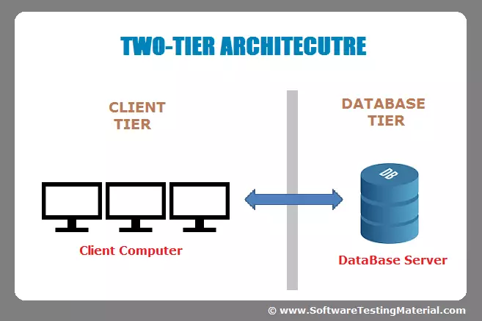

The Two-tier architecture is divided into two parts:

1. Client Application (Client Tier)  
2. Database (Data Tier)

Client system handles both Presentation and Application layers and Server system handles Database layer. It is also known as client server application. The communication takes place between the Client and the Server. Client system sends the request to the Server system and the Server system processes the request and sends back the data to the Client System

### ****Three-Tier Architecture:****

Three Tier applications is used for Web Based application

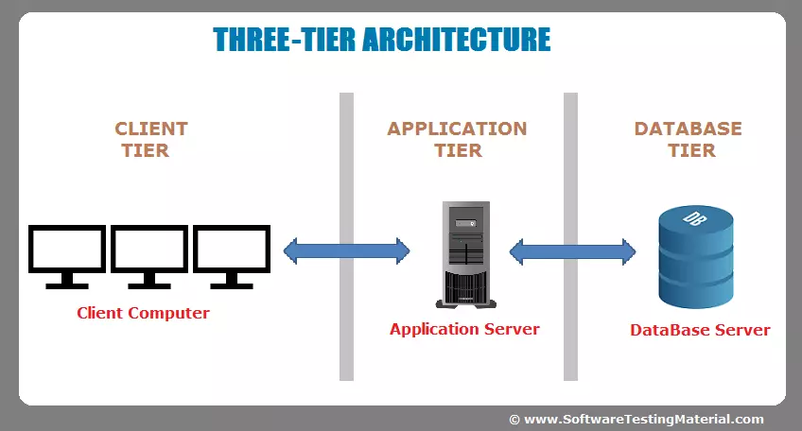

The Three-tier architecture is divided into three parts:

1. Presentation layer (Client Tier)  
2. Application layer (Business Tier)  
2. Database layer (Data Tier)

Client system handles Presentation layer, Application server handles Application layer and Server system handles Database layer.

### ****N-Tier Architecture:****

N-Tier application is used for Distributed application. It is also called **Multi-Tier** architecture. It is similar to three tier architecture but number of application servers are increased and represented in individual tiers in order to distribute the business logic so that the logic will be distributed.

**The n-tier architecture** is an industry-proven software architecture model. It is suitable to support enterprise level client-server applications by providing solutions to scalability, security, fault tolerance, reusability, and maintainability. It helps developers to create flexible and reusable applications.

A diagrammatic representation of an n-tier system depicts here – presentation, application, and database layers.

[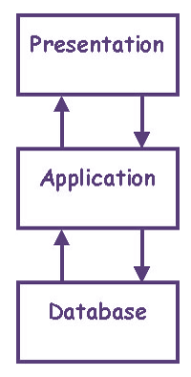](https://www.guru99.com/images/4-2016/042616_0902_NTierArchit1.png)

Some of the popular sites who have applied this architecture are

* MakeMyTrip.com
* Sales Force enterprise application
* Indian Railways – IRCTC
* Amazon.com, etc.

The advantages of Multi-Tier Architecture are

* Scalability
* Data Integrity
* Reusability
* Reduced Distribution
* Improved Security